**Batch Report Development Guide**

# Structure

# 

# Data Flows

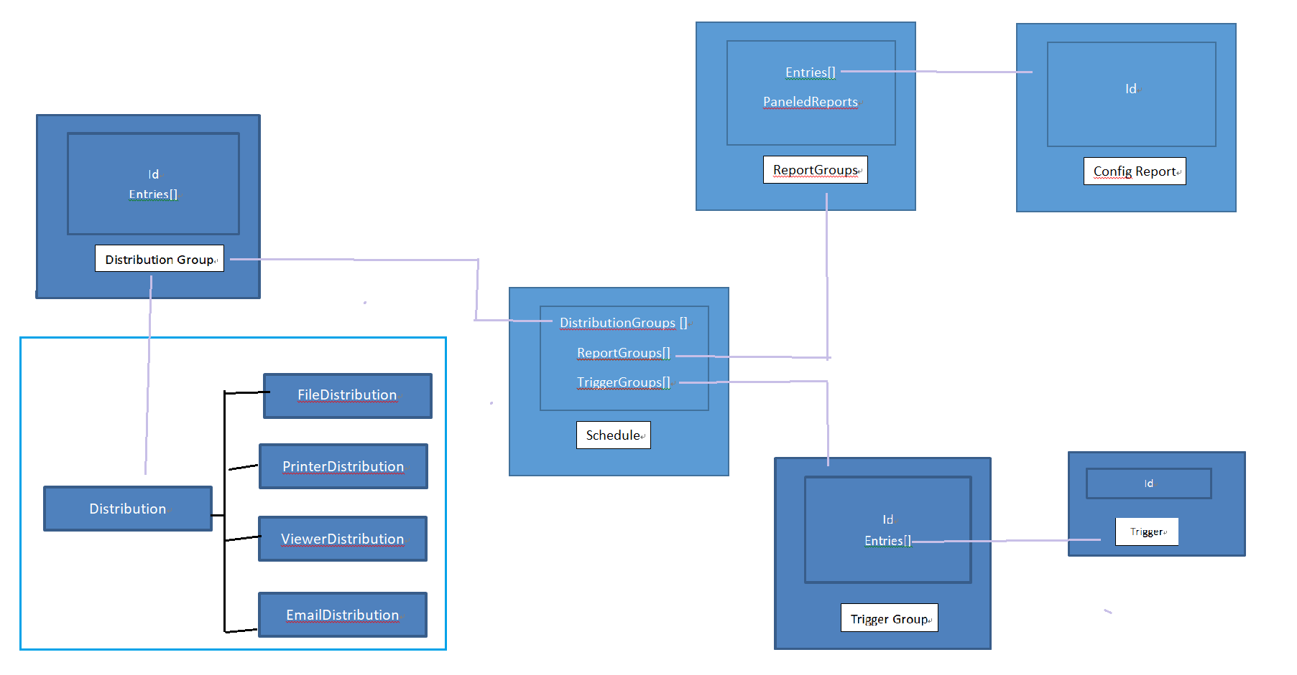

Batch Report Data Flows

# Schedule

# Batch Report was organized by Schedule, it includes New, Reload, Clone, Execute On Demand, Clone as UAT, Deep Clone, Delete functions etc.

# Note: Schedule Data Info includes three collections DistributionGroups [], ReportGroups[], TriggerGroups[] and so on.

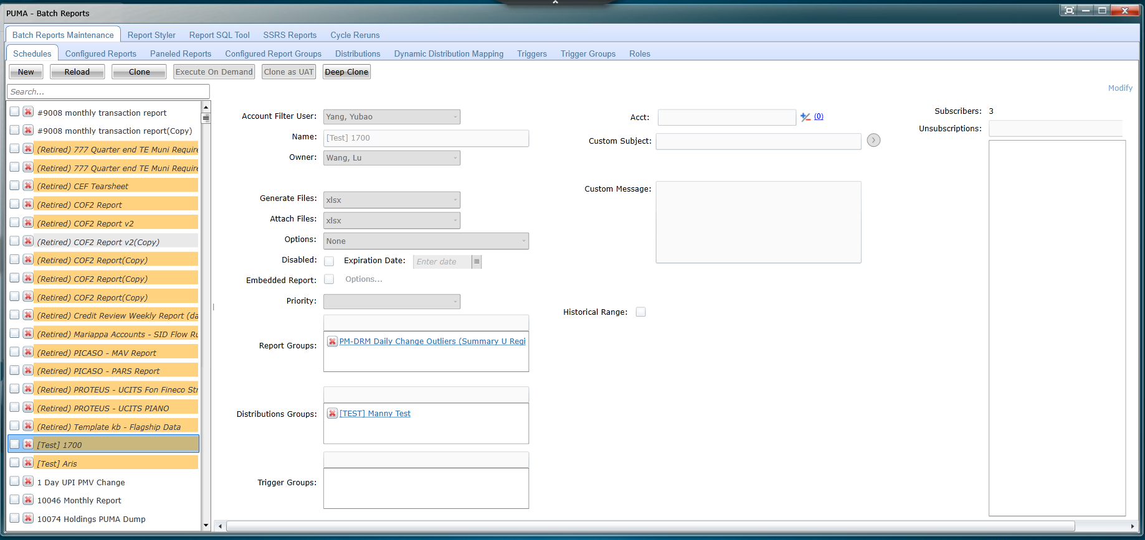

Data Structure

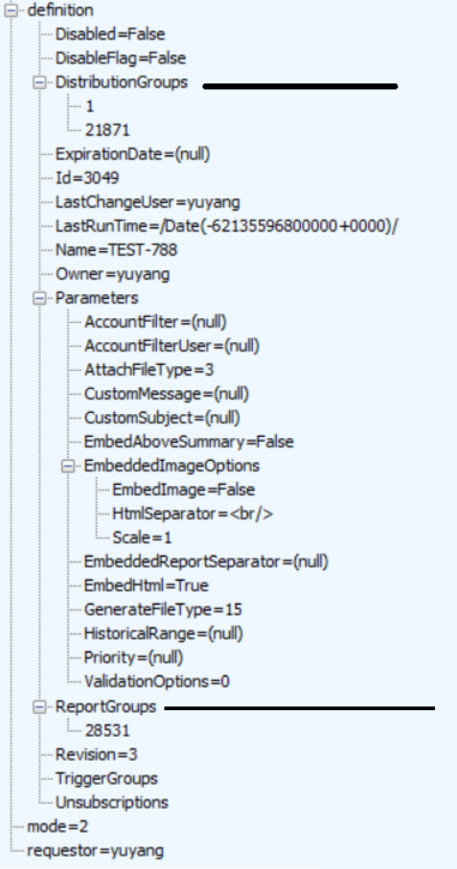

# Configured Report Group

# Configured Report Group includes Configured Report collections.

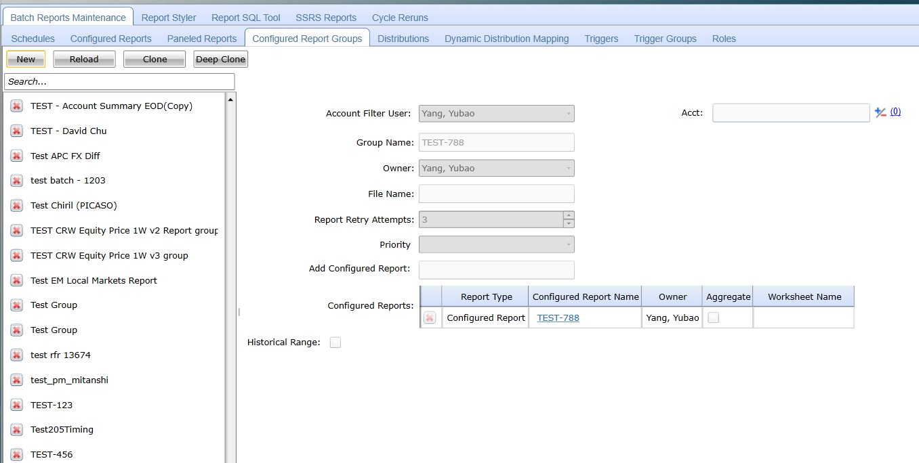

Data Structure

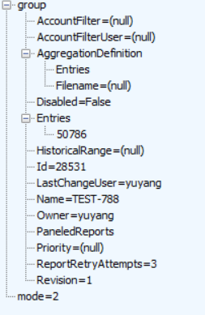

# Configured Report

# Configured Report includes New, Reload, Clone, Modify, Delete and Search functions etc.

# 

Data Structure

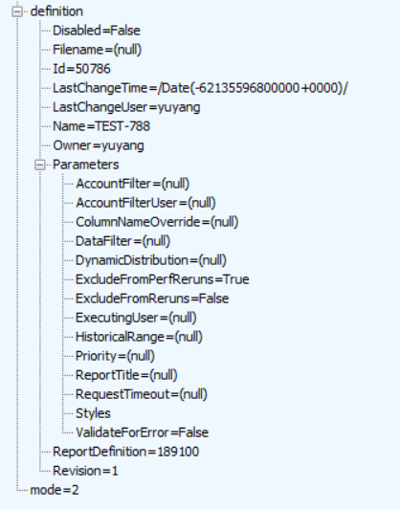

# Paneled Reports

# Paneled Reports likes Configured Report Group also is a way of to organize Batch Report. It at least has 1 Row and 1 Column.

# 

Data Structure

# 

# Distributions

# Distribution has four type: EmailDistributioin, ViewDistributioin, PrinterDistributioin, FileDistributioin.

# 

Data Structure

# 

# EmailDistributioin

# 

# ViewDistributioin

# PrinterDistributioin

# 

# FileDistributioin

# 

# Distributioin Group

# Trigger Group

# Trigger Group can contain multiple Triggers.

# 

# Data Structure

# 

# Trigger

# 

Data Structure

# 

# Create a new Batch Report

## 1 create on Query Inventory Viewer

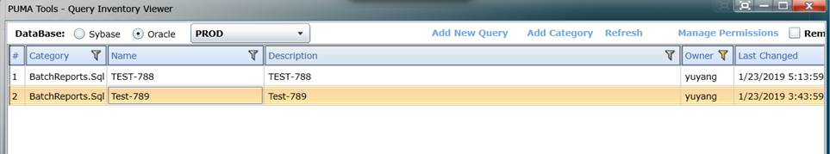

## 2 Add New Report on  “Report SQL Tool” tab on Batch Reports app. Please click Refresh button, if you can’t find you sql just created.

Note: Upper case and Lower case text 排序

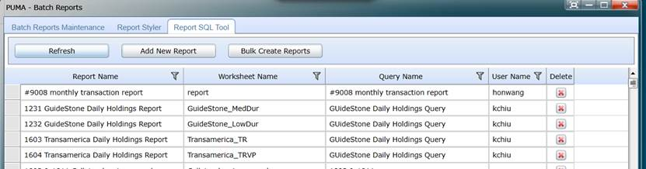

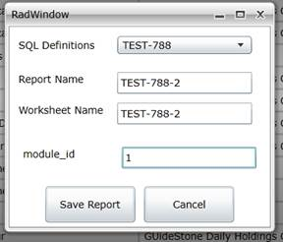

## 3 New a Configured Reports on sub-tab bin in Batch Reports Maintenance tab.

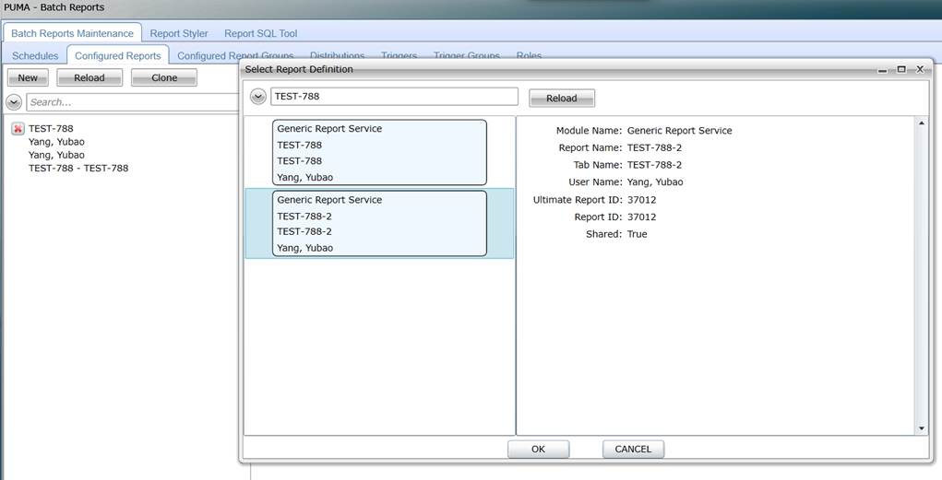

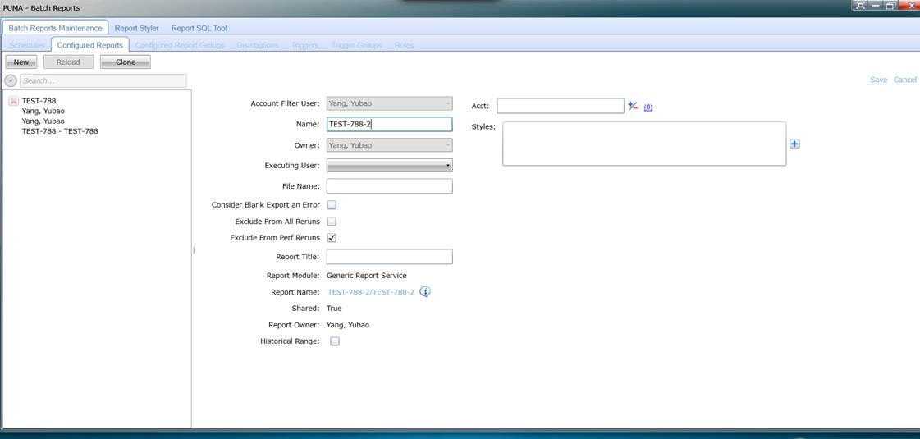

## 4 Configured Report Groups

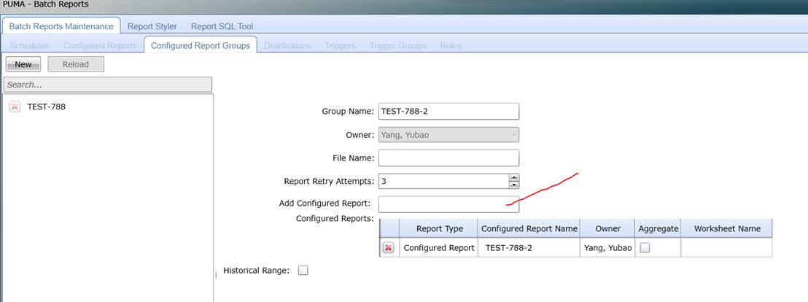

## 5 Distributions

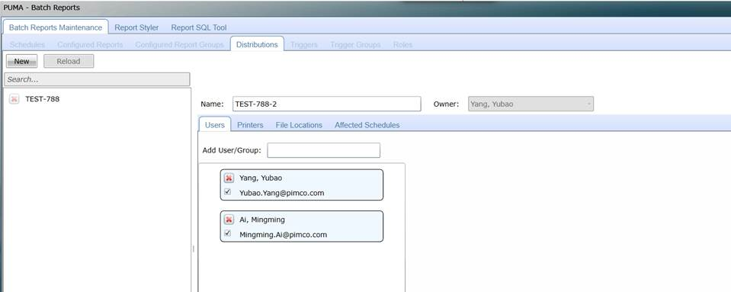

## 6 Schedules

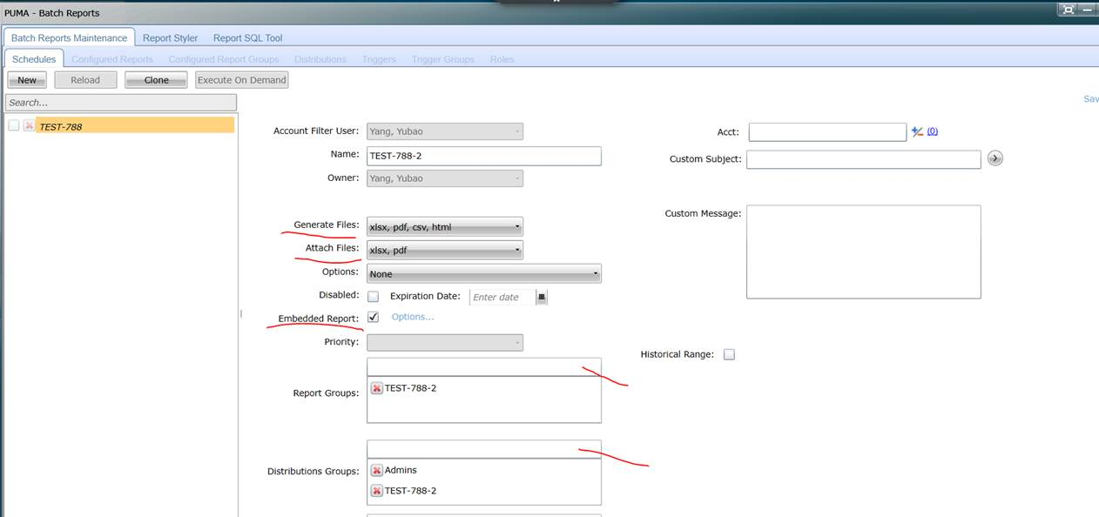

## 7 Execute on Demand

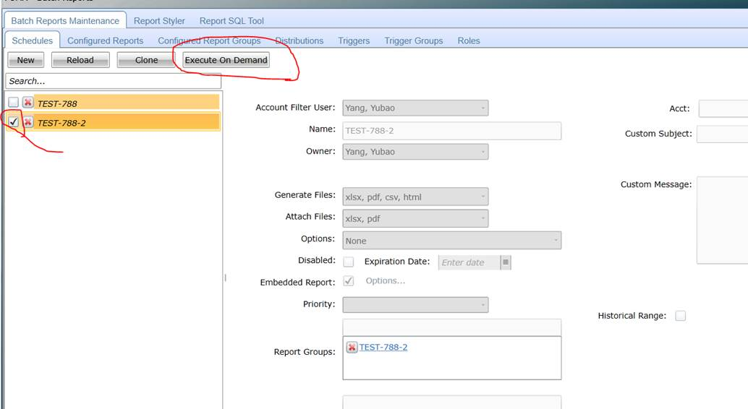

# Service Endpoint

PROD URL：<http://myreports.pimco.imswest.sscims.com>

BETA URL：http://myreportsbeta.pimco.imswest.sscims.com

1 Service Name： Controller Service

2 URL: <http://myreports.pimco.imswest.sscims.com/BatchReports/Controller>

3 Methods:

# 

1 Service Name：Maintenance Service

2 URL: <http://myreports.pimco.imswest.sscims.com/batchreportswcf/BatchReportsMaintenanceService.svc>

3 Methods:

# 

# 

1 Service Name：MyReports Service

2 URL: <http://myreports.pimco.imswest.sscims.com/MyReportsService.svc>

3 Methods:

# 

1 Service Name：Reportinfo Service

2 URL:[http://myreports.pimco.imswest.sscims.com/BatchReports/ReportInfo/](http://myreports.pimco.imswest.sscims.com/BatchReports/ReportInfo/healthcheck.html)

3 Methods:

# 

# 

# Debug Batch Reports Maintenance Service

# 1、Set as Start up Project

# 

# 2、Modify Web.Config

# 

Debug

# Debug Batch Report

* Set Puma.Container.Web as The StartUp Project
* Set Puma.Container.Web project debug settings:
  + Go to the Web tab in the Puma.Container.Web project settings
  + Choose "Specific Page" and enter "Default2.aspx?devmode=true&ServiceBrokerProfileId=BETA"
  + Enable Silverlight Debugging checkbox  
    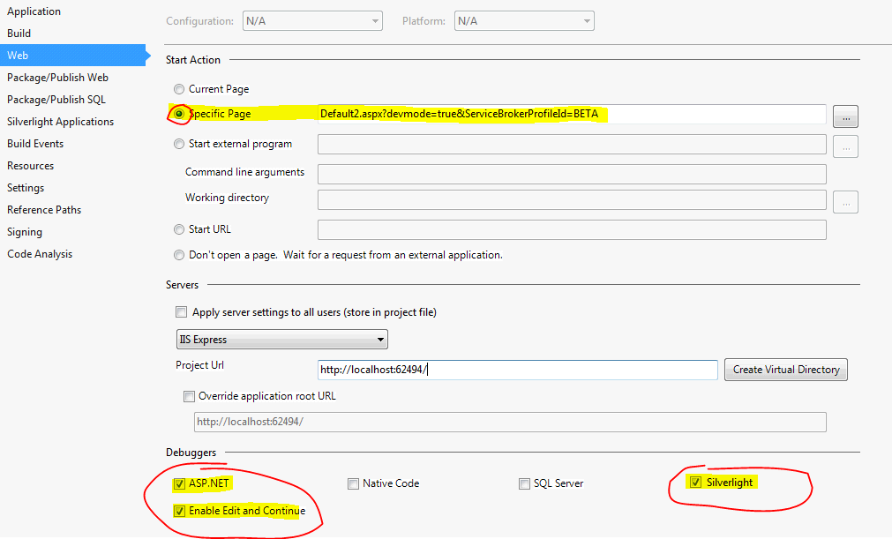
  + Set Silverlight Applications  
    Remove the default empty project and add the "BatchReportsClient"  
    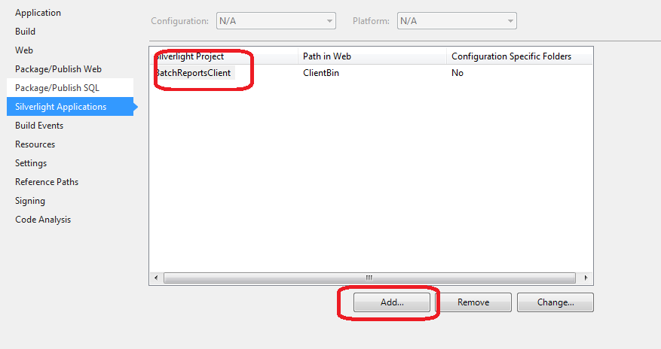
* Left click on the "Puma.Container.Web" project and open the "Properties" dialog in Visual Studio (Ctrl+W,P) to set the IIS Express settings
  + Disable anonymous authentication
  + Enable windows authentication  
      
    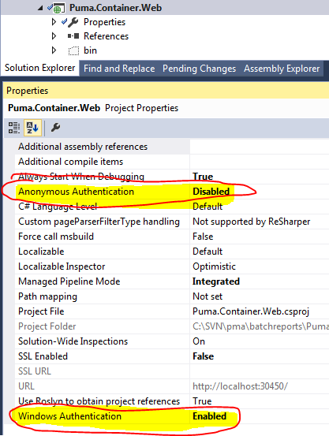
* Change ***DEV*** setting to ***BETA***(or***PROD***)
  + Apply these changes to Puma.Container.Web/config/include/Tiers.Configuration.xaml (around line 17):  
    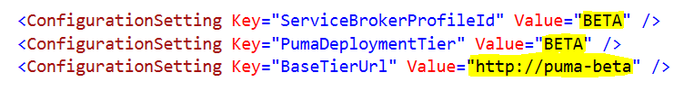
  + Apply this change to Puma.Container.Web/Helper/PumaDeployment.cs (around line 45):  
    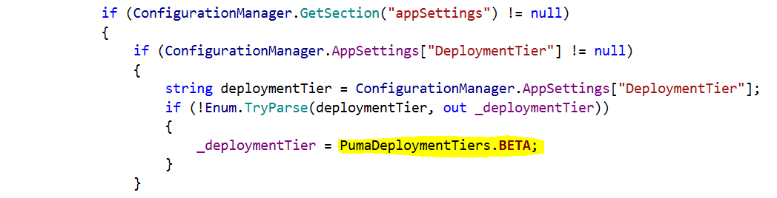
* Debug the application in Internet Explorer  
  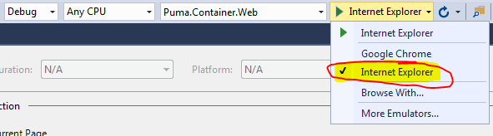

The API Batch Report Startup call

InsertToUserBehaviorLog

http://pmmt.pimco.imswest.sscims.com/silverlightlogwcf/UserBehaviorLog2/Database/InsertToUserBehaviorLog

GetAllSvcIncludedUsers

http://pmmt.pimco.imswest.sscims.com/pumadatawcf/ApplicationSecurityService/GetAllSvcIncludedUsers

GetAllGroupsAndMembers

http://pmmt.pimco.imswest.sscims.com/pumadatawcf/ActiveDirectoryService/GetAllGroupsAndMembers

GetAllModules

http://myreports/MyReportsService.svc/GetAllModules

GetPrinterInfoForRegion

http://myreports/MyReportsService.svc/GetPrinterInfoForRegion

GetAcctGroups

http://blottermt3/blotterdatawcf/DaemonService/GetAcctGroups

GetPrinterInfoForRegion

http://myreports/MyReportsService.svc/GetPrinterInfoForRegion

GetBlotterUserGroups

http://myreports/BatchReports/ReportInfoDAL/GetBlotterUserGroups

Get Role Data

<http://pmapps/roleservicewcf/RoleService.svc>

Develop Toos

SVN

QuickBuild

Snow-ticket

Slack

Wiki

JIRA

ForgeTeam